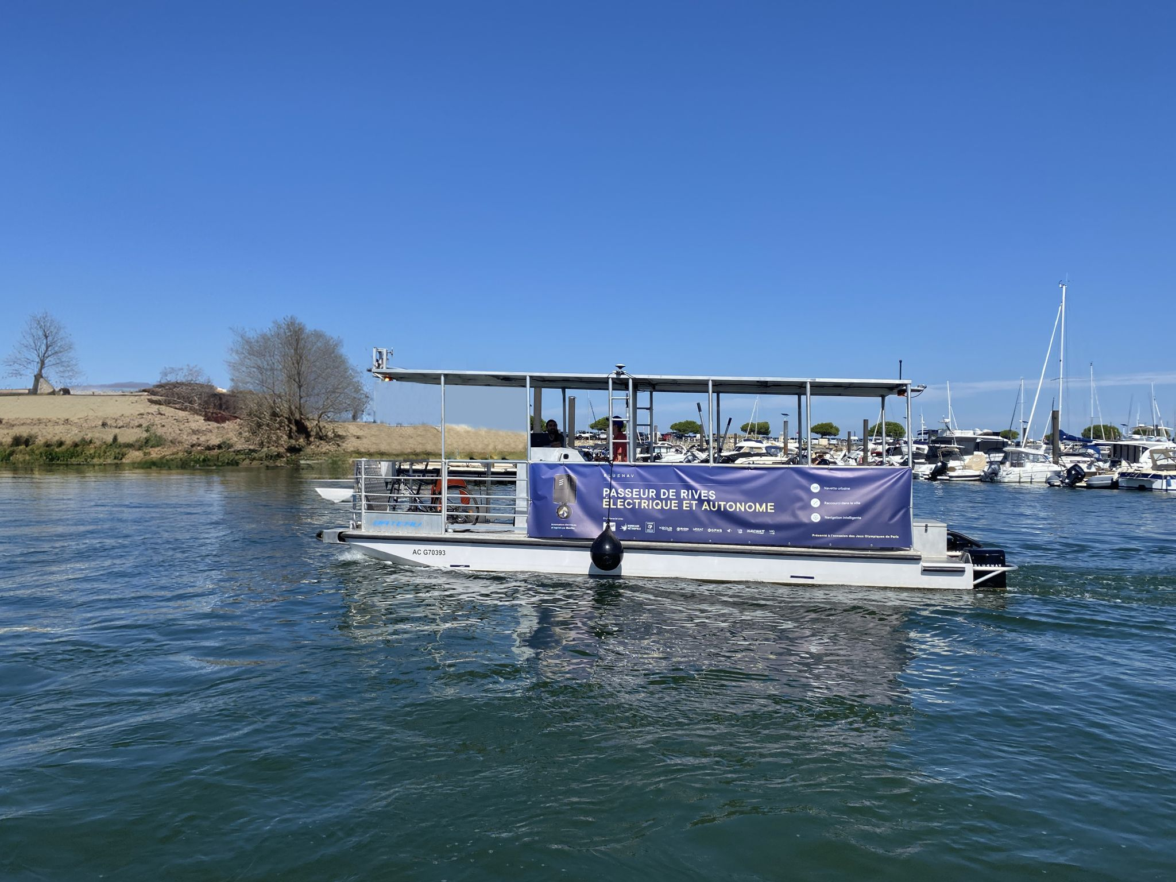

BlueNav presents its demonstration boat: autonomous with an electric propulsion

Arcachon, France, October 2024 – BlueNav, a company that creates “add-on” electric motors for boats and navigation assistance software solutions, presented its BlueBoat to the public for the first time on September 20th in Bordeaux.

Towards a progressive transformation of urban mobility

The increase in traffic on waterways accompanies an increasing automation of transport in all sectors, and particularly for river transport. In this context, the Paris 2024 Olympic Games represented a fantastic opportunity to promote the national river network, innovations around new uses of water, as well as innovative and decarbonized propulsion methods.

As the national operator responsible for promoting river transport, Voies Navigables de France (VNF), with the support of the Transport Innovation Agency, launched a call for projects for the implementation of demonstration boats for ferry services with automated navigation and low-carbon engines, BlueNav seized this major strategic opportunity, applied and won this challenge. Ultimately, this technology could be deployed on a larger scale, in other cities and situations.

The different actors of the project

BlueBoat is the project led by BlueNav, a French manufacturer of electric motors for the hybridization of boats. It is developed in association with Orion Naval Engineering, a naval architecture and engineering firm based in Bordeaux and Toulon, as well as with MOSAT / Drone Protect System, a company specialized in surveillance drones. They were joined by Bordeaux Métropole and its transport operator Keolis, committed to sustainable and connected mobility, and by Port of Bordeaux which will host the demonstration boat on its site. The objective of the French consortium is the development and construction of a 10-meter-long river boat, with a capacity of 12 seats, accessible to PRM (Person with Reduced Mobility) and with electric propulsion with autonomy level 4.

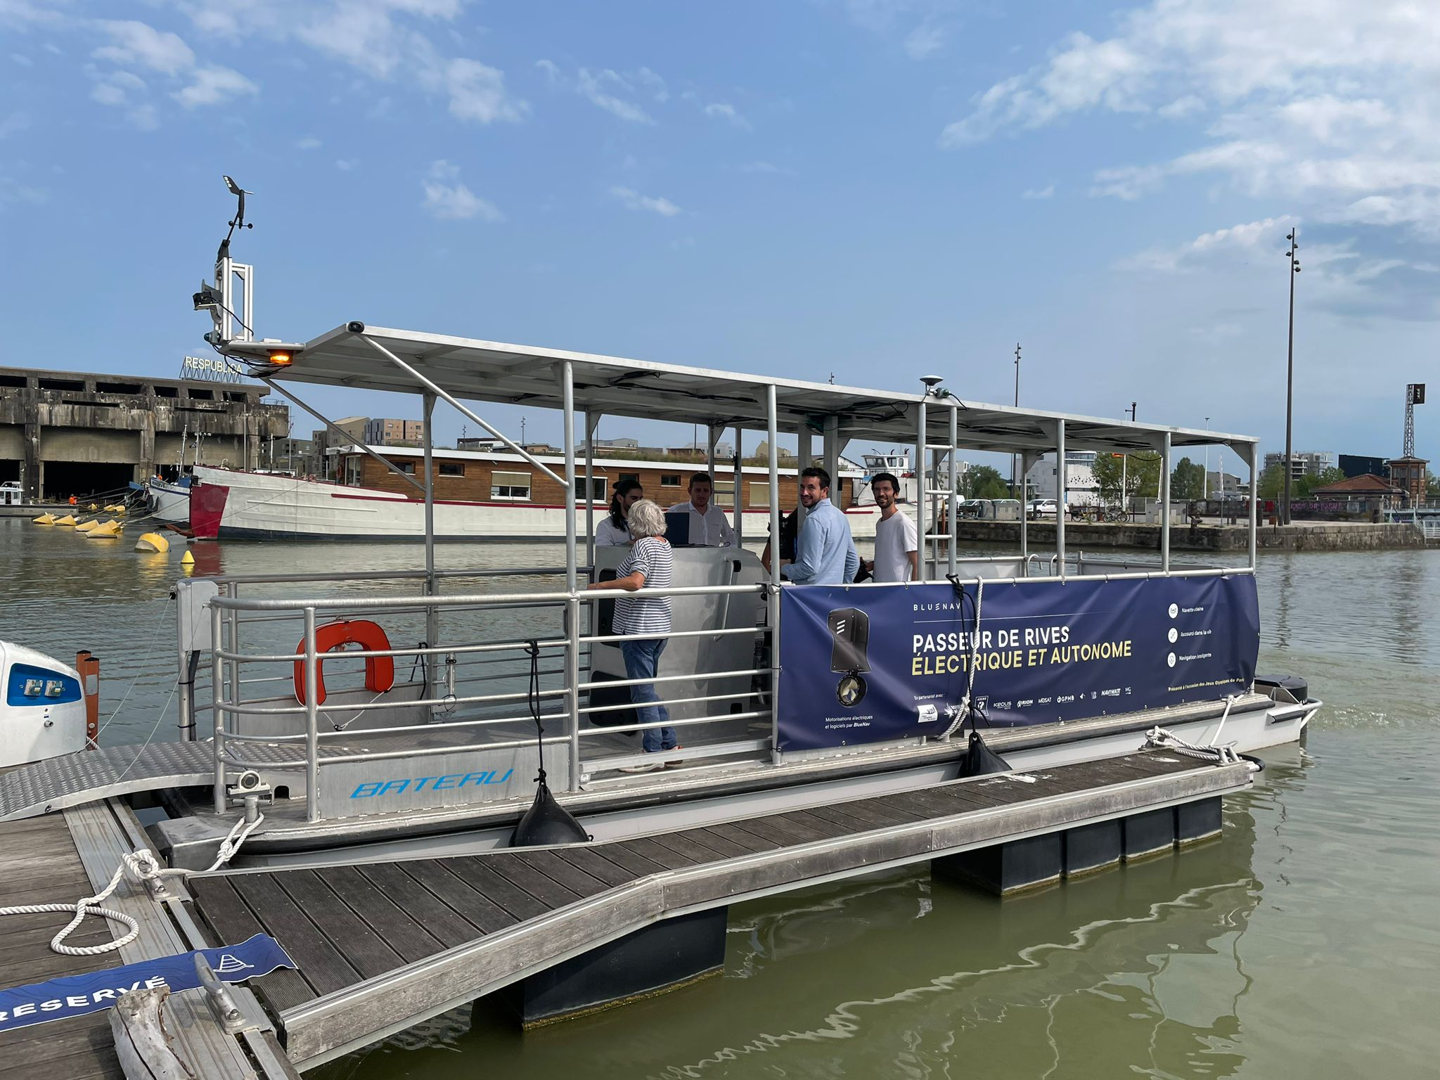

The various innovations of the electric and autonomous river crossing device

This river shuttle boat offers innovative and unique solutions, entirely developed by BlueNav:
• A pre-programmed route tracking
• An obstacle detection system (lidar radar)
• A virtual anchor
• An automatic docking system (docking + lowering of the gangway)
• 2 BlueSpin 15kw outboard electric motors

About BlueNav
BlueNav’s core mission is to accelerate the energy transition of boating, by improving the boating experience with smart, user-centric electric propulsion solutions for a sustainable future.
At the forefront of this mission is the development and design of “add-on” electric motors, manufactured in France, with the aim of converting any recreational boat into a hybrid electric boat. BlueSpin technology is an essential link between the conventional world of combustion engines and that of electric energy.
BlueNav stands out for its software with intelligent features designed to assist the pilot throughout its journey. It offers functions such as virtual anchor, mooring and fishing assistance, as well as movements controlled by a dynamic piloting system. The motors are retractable, rotatable, and offer 360° maneuverability. For more information: www.bluenav.com

Press contact :
Marie-Claire BONNET
marie-claire.bonnet@bluenav.com
+33 7 83 48 84 47

